Frequently Asked Questions FAQ’s

**EKO GEA**’s AD wastewater treatment (WwT)

& Anaerobic Digestion (AD) biogas production plants

1. How is it that the EKO GEA process produces NO SLUDGE and NO DIGESTATE?
2. How does the process accomplish digestion of all organics**?**
3. If there is no organic sludge, what happens to the inorganics**?**
4. How does the EKO GEA process produce so much more methane than conventional AD processes**?**
5. Grey water effluent from EKO GEA’s system - what is this? Can it be re-cycled or re-used? What are the benefits**?**
6. Does the bio-media in EKO GEA’s plant need to be cleaned, replaced, or re-charged in any way**?**
7. How is it that EKO GEA’s system promotes only microbes which are “beneficial” to the wastewater treatment and biogas production processes**?**
8. What is the maximum solids content for this system**?**
9. What other pre-treatments are required for the system**?**
10. How long does it take to commission an EKO GEA plant**?**
11. What are the operating costs of an EKO GEA’s plant**?**
12. If EKO GEA’s system does not produce digestate, how do we retain the NPK fertiliser nutrients on the farm**?**
13. Can I use a different bio-media, or must I use EKO GEA’s cristobalite**?**
14. How stable and user-friendly is the BCx additive? Is it a liquid or solid? How is it applied**?**
15. How many times faster, smaller and lower cost is EKO GEA’s system**?**
16. How much biogas uplift can I expect using EKO GEA’s processes**?**
17. What other benefits does the EKO GEA process offer**?**
18. Does the EKO GEA process require solids separation**?**
19. Can I make biogas from my wastewater**?**
20. Are EKO GEA’s residential WwT plants *CE 12566-3* certified**?**
21. **How is it that the EKO GEA process produces NO SLUDGE and NO DIGESTATE?**

EKO GEA’s process produces no *organic* sludge or digestate. All organic materials are digested and mineralised in the EKO GEA process.

1. **How does the process accomplish digestion of all organics?**

Microbes do the work in wastewater treatment and biogas production. The more microbial workers, the more diversity of microbes, and the healthier the microbes, the more efficient the digestion and cleaning process. First, EKO GEA’s process makes use of EKO GEA’s **BCx** Additive – assisting the breakdown of fat, carbohydrate, and protein nutrients in the hydrolysis stage, performing biological ion exchange to rid the hostile waste environment of ammonia and H₂S, breaking down long-chain-fatty-acids (LCFA’s) and essentially paving the way for microbial health and proliferation – feeding and protecting microbes in an unprecedented manner. **BCx** is at the core of EKO GEA’s technologies – it creates the robust biology which makes everything work. Then, EKO GEA’s process concentrates huge numbers of microbial workers into its porous bio-media – housing and protecting them. In conventional digesters and WwT plants, microbial “workers” are flushed out with every digestate and effluent release. In EKO GEA’s process, microbes are housed in a “fixed-film” where they live out their working lives, before dying and becoming food for other microbes. In EKO GEA’s process, microbes are “force-fed” nutrients as the waste filters through the bio-media housing.

See the difference, under a microscope. Microbes have been stained to “light up” in *Fig. 1*:

Microbes

in ***conventional***

digesters or

Wwater

treatment plants

Microbes

in **EKO GEA**

systems

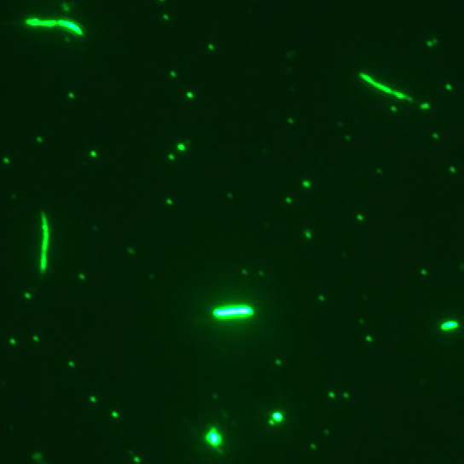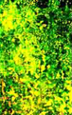

***Micrograph right*** *- Notice how* ***concentrated*** *the microbes are within* **EKO GEA’S** *bio-media?*

*More workers = better efficiency, and* **EKO GEA’S process** *produces* ***exponentially****-more microbes than conventional systems.*

***Fig. 1.******Micrograph left*** *- Notice how much space there is between microbes. Here, microbes have to “wait” to bump into food.*

1. **If there is no organic sludge, what happens to the *inorganics*?**

Some of the inert inorganic compounds flush out with the effluent grey water as very fine mineral particles. These are inert and need no further treatment. Some larger particulates will load into the bottom of the hydrolysis tank, over time, as a sand-like inorganic sludge – at a very slow rate. This inorganic “sludge” is not sludge as we know it because it is inert, mineralised inorganic material, not odorous, sticky, organic sludge. EKO GEA’S inert, sand-like sludge can easily be pumped out of the hydrolysis tank, but requirement for this activity is very infrequent and depends on the waste stream – every few years, at most. Note that this inorganic sludge does not require further treatment as it is fully mineralised and stable.

1. **How does the EKO GEA process produce so much more methane than conventional AD processes?**

BCx breaks down organic compounds into simple organic acids.  This feeds methanogen microbial populations over acid-forming populations, promoting more methane production than processes without BCx prebiotic support.  The ion exchange capacity in BCx plays a key role as AD processes cannot be optimised without biological ion exchange. See below for more about the science of methane-producing microbes.

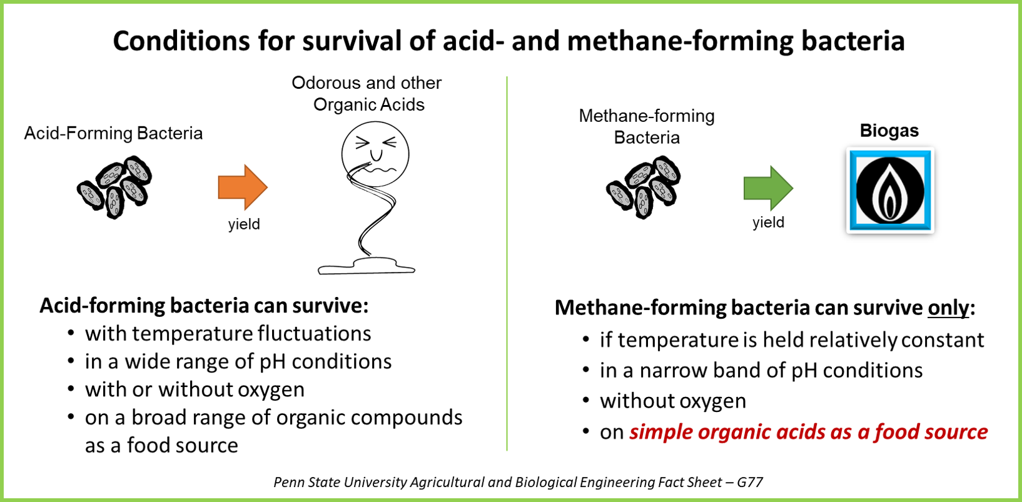

1. **Grey water effluent from EKO GEA’S system – what is this? Can it be re-cycled or re-used? What are the benefits?**

Grey water from EKO GEA’S system is beneficial as irrigation water because it is mineral-rich and full of beneficial microbial life for soils and plants. Healthy soil microbes are key to soil health and fertility. EKO GEA’S grey water does not have significant NPK fertilizer content, as these nutrients have been broken down and digested in the biological cleaning process, but farmers wishing to retain and manage nutrients for crops can hive off NPK-rich digestate before the full digestion process is complete – when fertilizer is required. Effluent grey water can be used as washing water, irrigation water, or re-cycled into EKO GEA’S system when water is required for diluting waste streams and biogas feedstocks. Microbes need water to function – something often overlooked by AD biogas experts and operators. Regulations in some territories require septic fields for effluent release from domestic sewage and packaged WwT plants. We will be happy to check requirements in your region to assure compliance.

1. **Does the biomedia in EKO GEA’S system need to be cleaned, replaced, or re-charged in any way (as carbon filters do)?**

No. EKO GEA’S cristobalite biomedia is vulcanized natural stone, specially sourced from a remote area of the world for the following properties: it is especially porous, robust, is 97% silica (glass), and it contains a huge amount of surface area in which the microbes lodge themselves to live and do their work, metabolizing waste. Unlike other porous silica stone, it does not contain “glass water” as all of this has been baked out of it in the geo-physical vulcanisation process, eons ago, underground. It also has great physical filtration capacity. Microbes consistently proliferate and digest waste. These same microbes “self-clean” EKO GEA’S biomedia – living, metabolising, digesting nutrients and dying – then becoming food for other microbes in EKO GEA’s system. EKO GEA’s biomedia does not need to be replaced – ever. Other sources of “fixed film” and “moving bed” bio-media often become clogged with microalgae and lignocellulose materials or the bio-films themselves. Unlike cristobalite, media like carbon and charcoal need to be regularly replaced. EKO GEA’S natural cristobalite is the ideal bio-media, and EKO GEA searched the globe for the very properties which set our cristobalite biomedia apart.

1. **How is it that EKO GEA’s system promotes only microbes which are “beneficial” to the wastewater treatment and biogas production processes?**

**BCx** additive is a superior growth media or food for microbes – feeding and protecting them, first by providing its unique ion exchange capacity which rids the environment of toxins (breaking down ammonia, H₂S and other free ions), then by providing unique nutrients (oligosaccharides and trace elements), then by its gelation properties. These protective and nutritive benefits serve to promote small, dynamic microbial colonies in the waste which then vastly outnumber and “competitively inhibit” pathogens and “bad” acid-loving microbial populations which prevent biogas production. Acid-loving microbes can survive on long-chain-fatty-acids (LCFA’s), but methanogens require simple, short-chain organic acids to thrive. **BCx** serves to break down LCFA’s to feed beneficial microbes the simple organic acids they require. These functions dramatically boost microbial health and proliferation. When we introduce **BCx** into waste or feedstock, microbes flourish. “Good” microbes are present in much greater numbers than harmful and pathogenic “bad” microbes – the earth’s survival to date proves this simple fact. EKO GEA is the only company in the world which approaches waste treatment by promoting microbial health (feeding and protecting) within indigenous microbial populations, harnessing them to do waste treatment work. **BCx** is the game-changing tool, with all its multi-functionality in a simple, user-friendly, affordable, and safe formulation. **BCx** is completely safe for application into the food chain – on crops, as animal feed, etc. Any biological process benefits from BCx, and EKO GEA manufactures a variety of formulas for many farming and industrial sectors.

1. **What is the maximum solids content for EKO GEA’S system?**

EKO GEA’S system can handle any organic solids content, but we will pre-treat and/or dilute waste streams to 8-12% solids before feeding it into our process. We use a mechanical pre-treatment technology which explodes waste and feedstock to reduce particle size to under 40 microns. Our proprietary explosion process liquefies and emulsifies even high-solids/high-strength feedstock which allows it to flow readily through EKO GEA’S process to complete digestion. We may dilute some higher-solids waste streams with water - using EKO GEA’S recycled grey water effluent, when warranted. All feedstock and wastes (except for human sewage in EKO GEA’s Wwater treatment plants) are macerated and exploded using EKO GEA’S hydrodynamic explosion process, completed in real-time in advance of feeding into the EKO GEA’S hydrolysis/sedimentation tanks. For some high-water-content waste streams like pig slurry and beverage waste, we utilise a simple mechanical concentrator to separate solids – another real-time innovation which allows EKO GEA’s process to minimise liquid handling, treatment, conveyance, and transport whilst maximising energy production from the solids portion. We can employ solids separation before or after treatment, entirely depending on customer needs.

1. **What other pre-treatments might be required for EKO GEA’s system?**

* Animal manure – wastewater treatment and biogas production - Solids separation is recommended if NPK nutrients are desired. This addresses a critical sustainability need for farmers:
  + Solids separation allows farmers to take advantage of the NPK fertiliser value needed by the crops on most farms - when needed (the liquid is treated to complete nutrient reduction and provide clean grey water effluent, and the solids portion is used for biogas production – or composted using **BCx** for high-quality compost within a 6-week timeframe). See Question 12, below for more information on nutrient management.
  + Note that BCx can be used in barns to take advantage of its odour-elimination and pathogen-reduction properties for a healthy, biological sanitation regime.
* Human sewage - Screening is required for human sewage – a standard wastewater treatment pre-procedure. No other pre-treatments are required – just BCx which is dosed upstream in the process – straight into toilets for small, residential systems.
* High-FOG (Fats Oils & Grease) waste streams like restaurant-grease-trap and slaughterhouse waste require light aeration + **BCx** to eliminate FOG before sending wastewater to EKO GEA’S system for complete cleaning.
* EKO GEA’s residential, domestic, packaged sewage treatment plants are CE 12566-3-certified to EU compliance.

1. **How long does it take to commission an EKO GEA plant?**

Due to the efficiency of EKO GEA’S system, operators do not require the long commissioning time required by conventional wastewater treatment plants and biogas digesters. EKO GEA’S system begins working immediately. We recommend waiting 1 week for compliance levels to be met on COD, BOD, TSS, N & P requirements and up to 3 months to reach peak biogas production (and stability) in biogas production applications. EKO GEA’S system efficiencies also mean a much smaller plant is required to do the work of huge installations. A smaller plant & footprint = lower capital costs.

1. **What are the operating costs of EKO GEA’S system?**

**BCx** is the only direct operating cost for packaged, domestic sewage treatment. Larger residential plants may make use of pumps to move sewage. AD biogas production plants require energy for pre-treatment maceration and explosion of high-solids waste/feedstock to reduce particle size and emulsify the waste. **BCx** is dosed at 50ml/m³ for residential sewage wastewater treatment and up to 250ml/ m³ for biogas production and very high-strength, challenging waste streams like MSW (municipal solid waste) leachate.

1. **If EKO GEA’S system does not produce digestate, how do we retain the NPK fertiliser nutrients needed on our farm?**

When NPK nutrient retention is desired, the EKO GEA system is designed to enable growers to hive off digestate before it finishes the cleaning process – when fertilizer is desired. Solids-separation step can be employed before or after treatment, with the liquid going to EKO GEA’S WwT system (for cleaning) and the solids going into biogas production or compost. This is the most efficient and effective way to achieve a closed-loop sustainable farming solution for waste treatment, nutrient management, and renewable energy production. See “*Closed-loop EKO GEA Solution for Farming*” on our website for a full explanation. With EKO GEA’s intervention, farmers can keep everything on the farm – water, nutrients, energy, and carbon – to meet sustainable practices and renewable energy needs.

1. **Can I use a different bio-media, or must I use EKO GEA’s cristobalite bio-media?**

You must use EKO GEA’s cristobalite bio-media. We have searched the earth for the ideal bio-media, and our cristobalite is robust, porous, and over 96% silica. Its properties account for the ability of EKO GEA’S SYSTEM to house and concentrate vast armies of microbes into a small space. Note that other forms of natural stone bio-media:

* Degrade over time (ours is “vulcanized”, geologically, and never needs replacing)
* Are much higher in aluminium which interferes with biological performances
* Are not as porous – Every m³ of our cristobalite bio-media = 1 km² of surface area for microbial “workers”
* Are often filled with “glass water” which takes away from the surface area which can be utilised to house microbes
* Are not as lightweight and do not have the hydroscopic (unaffected by water) characteristics which defines our bio-media

1. **How stable and user-friendly is the BCx additive? Is it a liquid or solid? How is it applied?**

**BCx** is a liquid concentrate, has a 5-year shelf life and is stable in concentrate form as long as it is stored out of direct sunlight. It must be diluted with water to activate it (and microbes need water). Once diluted, the shelf life of **BCx** is reduced to several days only. To dose any waste stream, just dilute it in water at the recommended dosage/dilution, and add to all incoming, new waste. Mixing ensures good distribution throughout the microbial populations, so mixing is recommended when possible. EKO GEA’s packaged, residential WwT plants are simply dosed with **BCx** by adding 100 ml to the toilet once per week and flushing twice after to mix and dilute it properly.

1. **How many times faster, smaller and lower cost is the EKO GEA’s system?**

This depends on the waste stream which can vary hugely in concentration. A laboratory analysis will always be required before any industrial EKO GEA system can be sized and quoted (with the exception of human sewage, for which we provide standard, pre-fabricated systems). As a rule, EKO GEA’s process is several orders of magnitude *faster, smaller, and lower cost* than conventional wastewater treatment and biogas production systems, ***after*** the cost of **BCx** is factored into operating costs.

1. **How much biogas uplift can I expect using EKO GEA’s processes?**

Feedstock determines biogas production levels. Feedstock biogas and methane potentials for various feedstocks are published and available in many textbook and internet publications, but, it should be noted, real-world biogas/methane production rarely achieves textbook levels on a consistent basis. Adding **BCx** additive to feedstock in AD processes provides no less than a than 30% biogas uplift from textbook levels. Using our micronisation pre-treatment and our biomedia filtration processes produces even more biogas uplift- several orders of magnitude more than traditional biogas technologies.

1. **What other benefits does the EKO GEA process offer?**

Biogas quality is also increased with EKO GEA’s process, including negligible H₂S. Odour is eliminated in any EKO GEA process, due to the ion exchange capacity of our **BCx** additive.

1. **Does the EKO GEA process require solids separation?**

Solids separation can be employed to cut costs, water use, liquid handling/treatment requirements, and transport needs. Customised solutions are designed for each plant and customer to meet each customer’s specific requirements and wishes.

1. **Can I make biogas from my wastewater?**

Domestic and commercial sewage do not contain enough nutrients for biogas production. We are happy to discuss biogas production for any suitable, high-strength waste stream.

1. **Are EKO GEA’s residential WwT plants CE 12566-3 certified?**

All EKO GEA residential, packaged WwT plants carry CE 12566-3 certification. Our plants have undergone stringent testing for water-tightness, structural strength, and treatment efficiency performance, including 38 weeks of testing to mimic stress loading periods, dis-use during holiday-periods, etc. Effluent is required to meet EU standards.

For additional information, visit our website <www.ekogea-int.com>.

